**Prerequisites**

|  |  |
| --- | --- |
| Date | 07 November 2022 |
| Team ID | PNT2022TMID14574 |
| Project Name | AI BASED DISCOURSE FOR BANKING INDUSTRY |

**Screenshots of IBM Account Registration:**

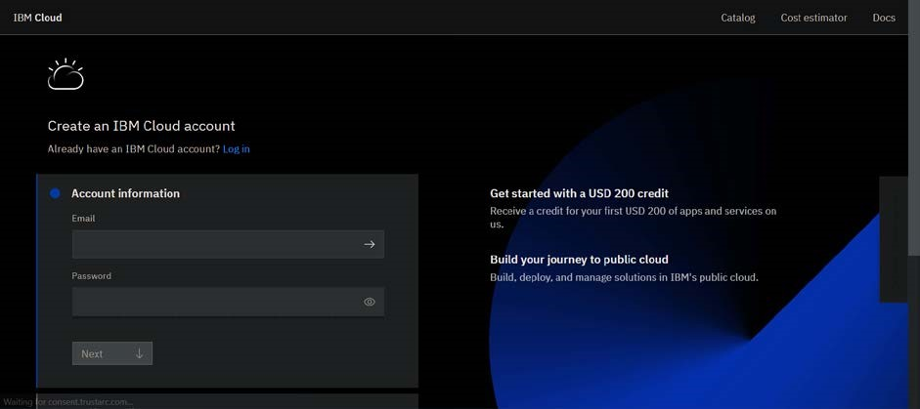

**Screenshots of IBM Account Login:**

